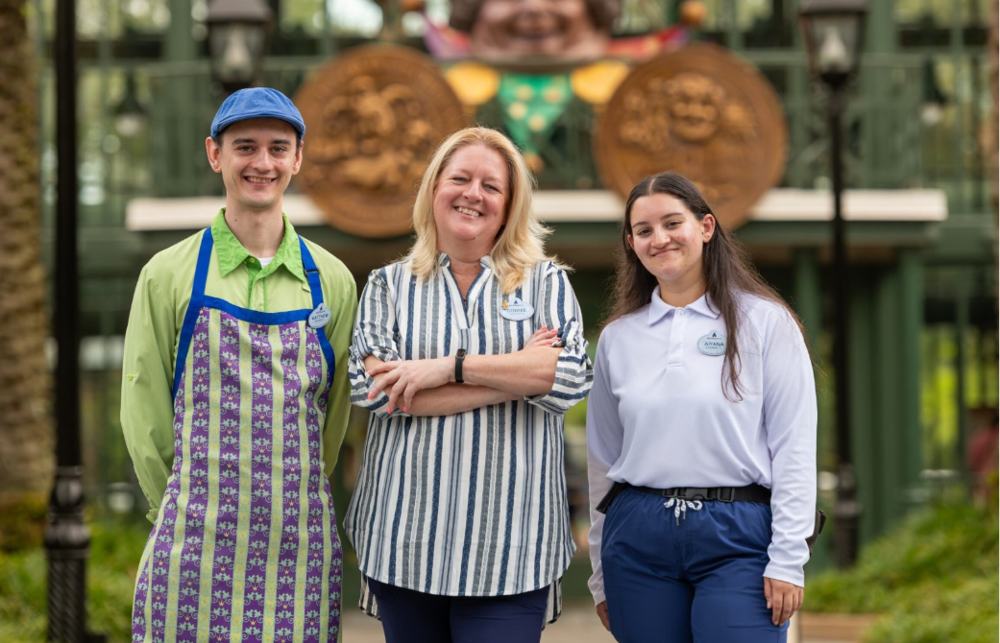

Celebrating Disney Moms
For generations, Disney has been a place where families grow together, not just through shared memories, but through meaningful careers. For many cast members, a Disney journey begins at home, inspired by mothers whose dedication and perseverance opened the door to opportunity. This Mother’s Day, we are celebrating Disney families and the women who help shape them, spotlighting moms whose careers at Disney have created pathways for their children and strengthened the bonds that connect generations across our parks and resorts.
For Connie, a career at Walt Disney World Resort began with a simple weekend job and grew into a lifelong journey.
Connie joined Disney World at just 16 years old while still in high school. What started as an after-school job soon became the foundation of a career that has spanned more than 35 years. Over the decades, she worked across parks and resorts before moving into Workforce Management, where she has supported thousands of cast members behind the scenes since 2005.
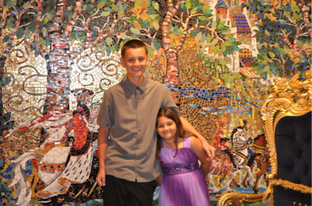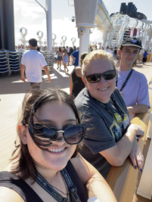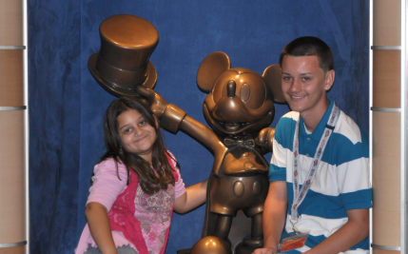
Matthew, Aiyana and Connie on vacation through the years with Disney
At the same time, Connie was raising her two children on her own, with Disney World becoming a second home for their family. From days spent in the parks and water parks to cruises together, Disney was always part of their everyday life. More importantly, her children grew up watching their mom build a career she was proud of, one step at a time.
Today, that connection has come full circle.
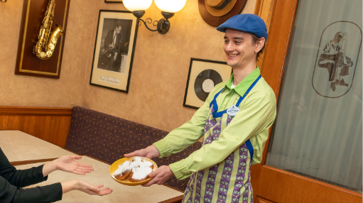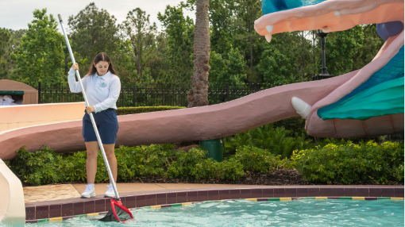
Matthew and Aiyana working at Disney’s Port Orleans Resort
Connie’s son, Matthew, now works in food and beverage at Disney’s Port Orleans Resort, where he connects with guests while pursuing his passion for pastry and culinary arts at Valencia College through Disney Aspire, the company’s education investment program. Her daughter, Aiyana, recently joined Walt Disney World and is beginning her own journey, inspired by the example she grew up watching. She is studying business administration through Disney Aspire and hopes to one day step into a leadership role.
“Growing up, I always saw how much my mom cared about what she did,” Matthew said. “Watching her build a career here at Disney made me want to find something I’m passionate about too, and Disney has given me the chance to do that.”
Seeing their mom grow within the company left a lasting impression.
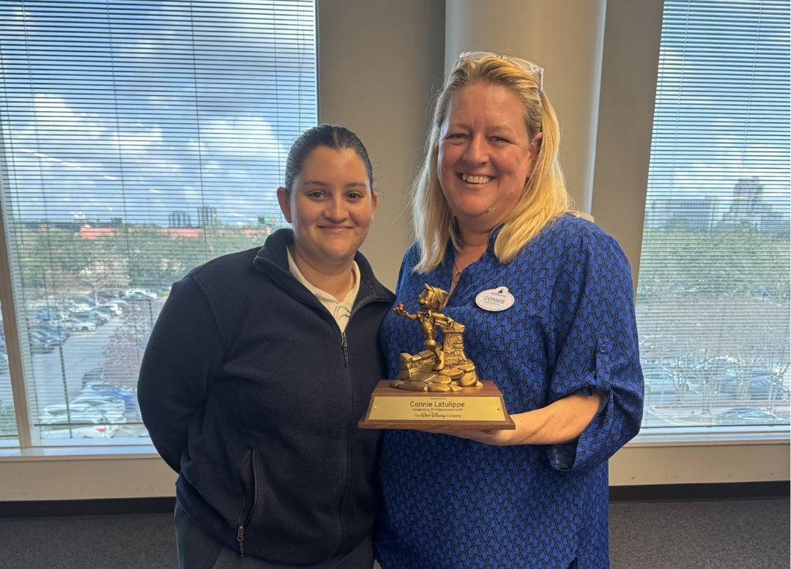
Aiyana and Connie celebrating Connie’s 35-year Service Anniversary
“Watching my mom build her career has really inspired me,” Aiyana, said. “It pushes me to work hard, keep learning, and believe that one day I can build something just as meaningful.”
Working at the same company has given the family a new way to connect, from sharing everyday work experiences to celebrating milestones together. Connie says watching her children build their own journeys has been one of the most rewarding parts of her career.
“One of my proudest moments has been seeing my kids find their own paths here,” Connie said. “Disney has supported me through every stage of my life, and now I get to see that same support extended to my children.”
This Mother’s Day, Connie’s family celebrates more than a career. They celebrate a legacy of growth and opportunity passed from one generation of cast members to the next.
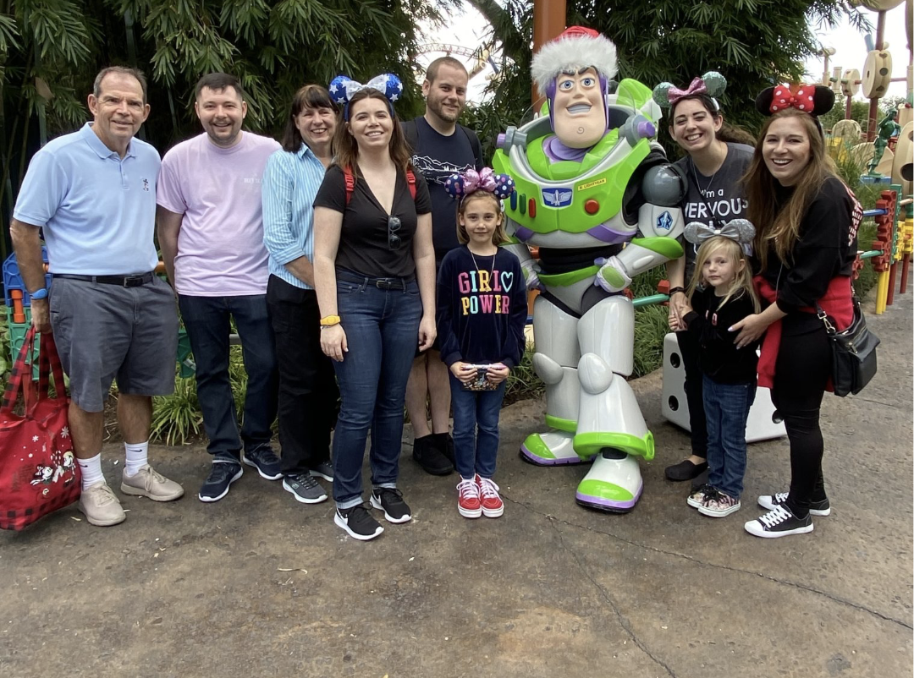
Jenny (pictured in blue) along with her entire family including her daughters Andie, Kellie and Jessica on vacation at Disney’s Hollywood Studios park in 2019.
Across the country at Disneyland Resort, one mother’s journey sparked a legacy that continues to inspire across generations. For the Sweetman family, that inspiration began with Jenny Sweetman.
Jenny joined Disneyland Resort in 1983, stepping into her first role as a hostess in New Orleans Square. What followed was not just a career, but a lifelong journey shaped by growth, opportunity, and an unwavering commitment to people. Over the next four decades, she built experience across nearly every corner of the resort.

While Disneyland Resort shaped Jenny’s professional path, its impact extended far beyond her own career. As her three daughters grew up around the parks watching their mom show up with pride, care, and purpose they also began to imagine futures for themselves as part of that same magic.

“As kids, we didn’t always understand what our mom did,” shared her daughter, Jessica. “We just knew she worked at Disneyland, and that meant something. We saw how much she loved what she did, and how much she cared about the people she worked with.”
Jenny balanced leadership roles with motherhood, modeling what it meant to be an amazing leader while staying fully grounded in her family. She never charted a specific path for her children but showed them how meaningful work could be.

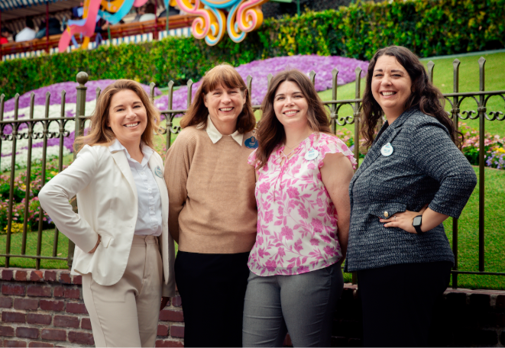
Jessica, Jenny, Andie and Kellie just inside the gates at Disneyland

“I just wanted them to know they could do anything,” Jenny said. “Disney gave me the space to grow, and I wanted them to feel that same kind of possibilities for themselves.”

Kellie was the first of Jenny’s daughters to follow in her footsteps, joining Disneyland Resort in 2011 and beginning her own leadership journey. Over the years, she built experience across several operational areas, taking on new challenges and eventually advancing into roles focused on safety. Along the way, she pursued higher education with the support of Disney's Educational Programs, continuing the legacy of growth and leadership she watched her mom model firsthand.
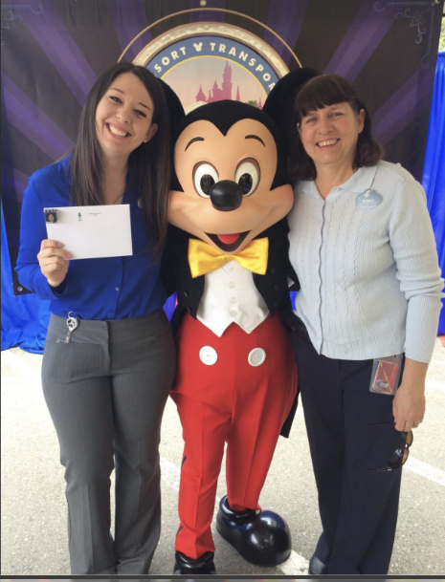
Jenny celebrating her daughter Kellie’s 5-year Service Anniversary.

Not long after, Andie joined the resort, starting her career in retail while working toward a degree in Hospitality Management. From supporting major park moments, to exploring creative roles, she once only dreamed about, Andie credits her mom for fostering independence and confidence.
Nearly 30 years to the day after Jenny’s first role began, Jessica hired into Disneyland Resort, starting in the very same land where her mom’s journey first began. A beautiful, full circle moment. Years later, with the help of Disney Aspire, she earned her MBA and now works in Communications, helping tell Cast stories across the resort.
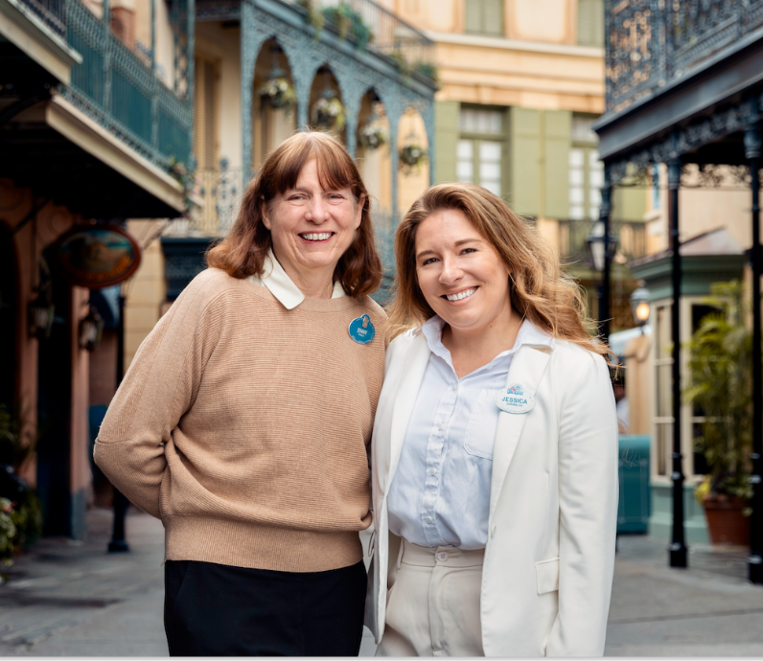
Jenny and Jessica in New Orleans Square the place where it all began

At Disney, Cast Members do not just find a job, they find a place to belong, to grow and to build careers that often span an average of 12 years.

This Mother’s Day, we’re celebrating Jenny and moms like her, whose love for the parks and dedication to people help keep the magic moving forward one family, one career, and one generation at a time.

These stories remind us that Disney is more than a place to work. It is a place where passion is passed down and futures take shape across generations. Through leadership, mentorship, and example, Disney moms continue to inspire not only their own families, but cast members across our parks and resorts, leaving a legacy that lives on in the magic they help create every day.

